**IBM’s Power 10 Private Cloud Rack for Db2 Warehouse - Chapter 3: Step-By-Step Guide to Engage IBM Support**

**By Sachin Jain and Jana Wong**

Running mission-critical workloads demands more than just cutting-edge hardware—it requires fast, reliable support when issues arise. With the release of IBM's Power 10 Private Cloud Rack for Db2 Warehouse Solution, IBM has enhanced scalability, resiliency, and deployment flexibility. To complement these innovations, **IBM offers the option to purchase the Advanced Support Cartridge, providing customers using Db2 Warehouse on Power10 with a streamlined, Single-Point-of-Entry support experience.**

This blog post—the third in our series—builds on the foundational overview provided in [Introducing IBM’s Power10 Private Cloud Rack for Db2 Warehouse Solution: Architecture, Scalability, and Performance](https://community.ibm.com/community/user/datamanagement/blogs/jana-wong/2025/03/07/introducing-ibms-power10-private-cloud-rack-for-db) and the performance insights shared i[n Power10 Private Cloud Rack for Db2 Warehouse Solution: Performance Deep Dive](https://community.ibm.com/community/user/blogs/jana-wong/2025/04/24/ibms-power10-private-cloud-rack-for-db2-warehouse). For guidance on setting up your environment, be sure to also review the detailed [Deployment Guide](https://www.ibm.com/support/pages/node/7028725), which outlines the deployment for Db2 Warehouse, hardware, software, and infrastructure requirements for Power10-based systems.

In this blog post we provide a step-by-step guide for engaging IBM Support, ensuring customers receive the right assistance from the right teams at the right time. Notably, this support process is consistent with the model used across other IBM products, such as Db2, offering customers the benefit of a familiar, streamlined experience that simplifies issue resolution and accelerates time-to-value.

The following flowchart outlines the support process for Db2 Warehouse on Power10 when customers first encounter an issue and need assistance through to resolution.

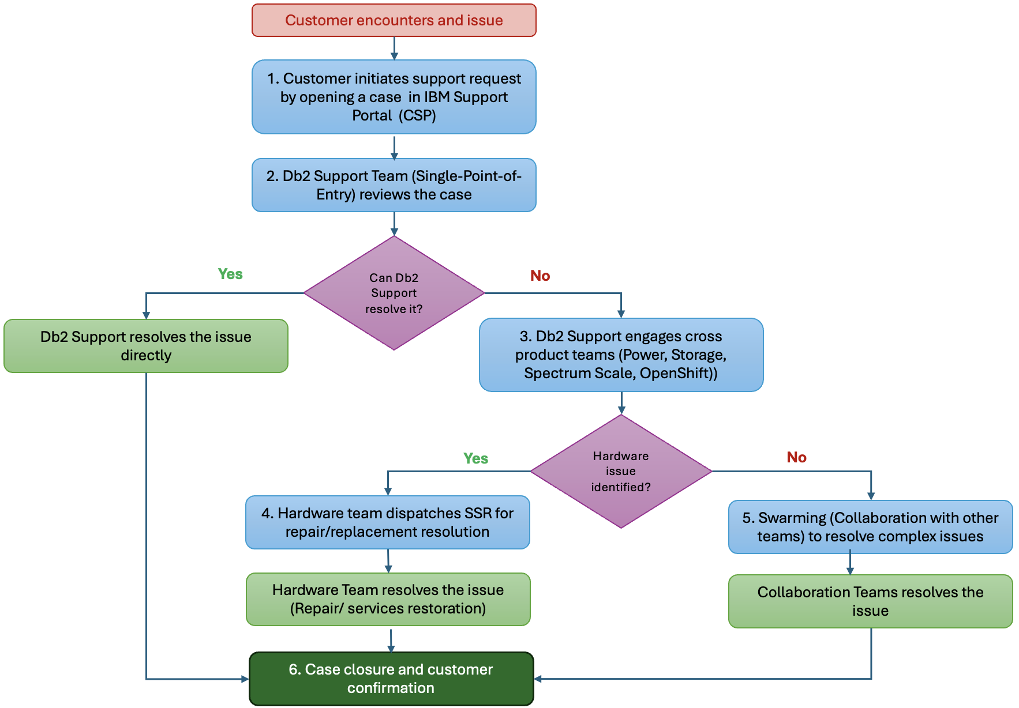

***Figure 1:*** *Flowchart: Navigating Support for Db2 Warehouse on IBM’s Power 10*

Next, we will take a closer look at each step in the process to provide deeper insight and guidance.

**Step #1: Customer Initiates the Support Request**

The support process begins when a customer initiates a support request by opening a ticket through the [Customer Support Portal (CSP)](https://www.ibm.com/mysupport/). To do so, navigate to the portal and click on "Open a Case." When completing the form, be sure to select **"Db2 Warehouse Solution Stack"** as the product and provide all relevant details, including the case severity, a clear description of the issue, and any additional necessary information. Supplying comprehensive information at the outset helps expedite the support process and ensures that the case is routed appropriately. The image below displays a sample case template as it appears when a ticket is submitted through the Customer Support Portal (CSP).

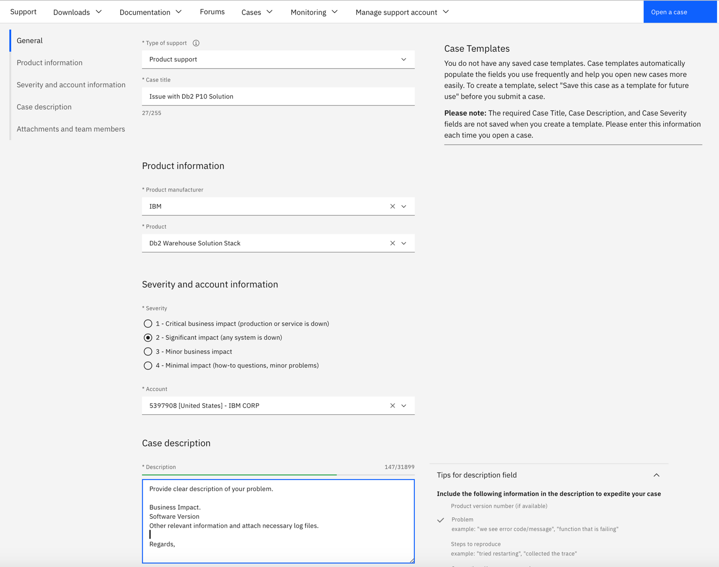

***Figure 2:*** *Case Template for opening a new support ticket through the CSP*

To follow up on an existing case, navigate to the “View My Cases” section and select the relevant case from your list. If there is an ongoing case that requires additional information, providing updates within the existing case ensures continuity and helps the IBM Support team resolve the issue more efficiently.

**Step #2: Single Point of Entry (SPOE): Db2 Support Team**

In Step 2, the **Db2 Support Team** serves as the **Single Point of Entry (SPOE)** for all tickets related to the Db2 Warehouse Solution Stack. Upon receiving a support ticket, the Db2 Support Team evaluates the issue and determines the appropriate next steps. Depending on the nature of the problem, they may either resolve the issue directly within the Db2 support scope or engage additional specialized teams—such as Power, or Storage —as needed to ensure a complete and efficient resolution.

**Step #3: Engaging Cross Product Teams**

In Step 3, if an issue requires support for Power, Storage, or other software components, the Db2 Support Team will engage the appropriate teams by opening a Skills Case. The respective Support Missions will be brought in as needed to address specific aspects of the issue. All IBM Support teams operate under established **Business As Usual (BAU)** procedures, ensuring a consistent and coordinated approach to problem resolution across all involved groups.

**Step #4: Handling of Hardware Issues**

In Step 4, if the investigation determines that hardware repair or component replacement is required, the Hardware Support Team will dispatch a Service Support Representative (**SSR**) with the necessary parts to complete the repair. Appropriate support teams will also be engaged to ensure a smooth repair process and the prompt resumption of Db2 services. To further streamline support, IBM highly recommends enabling the **call-home capability** via the Hardware Management Console (HMC). When call-home is activated, an automatic support case is created, allowing IBM Support to proactively manage hardware-related issues. For guidance on enabling the call-home feature, please follow the instructions [here](https://www.ibm.com/docs/en/power10?topic=clcress-configuring-hmc-so-that-it-can-connect-service-support-by-using-call-home-setup-wizard).

**Step #5: Coordination for Complex Issues**

In Step 5, when complex, multidisciplinary issues arise that require collaboration across teams—such as Db2, Power, and Storage—the Db2 Support Team will manage the overall coordination. The Db2 team will engage the necessary groups by opening Skills Cases as needed, facilitating communication and collaboration among the involved support and development teams. The primary goal is to ensure seamless teamwork and efficient resolution of complex issues, minimizing disruption to customer operations.

**Step #6: Case Monitoring and Closure**

In Step 6, the Db2 Support Team continues to monitor progress across all engaged teams to ensure timely resolution and case closure. This approach aligns with the support model used across other IBM products, providing customers with a familiar and streamlined experience that simplifies issue management and accelerates time-to-value.

**Conclusion**

In complex enterprise environments, seamless support is critical to maintaining performance and availability. When customer purchases Advanced Support Cartridge for Db2, they are essentially designating Db2 Support as the single point of entry and orchestrating collaboration across specialized teams like Power, Storage, Spectrum Scale, and OpenShift, IBM ensures that customer issues are addressed quickly and efficiently. Whether it’s a simple software question or a cross-stack hardware incident, this structured support workflow empowers customers to navigate challenges with confidence, keeping their Db2 Warehouse on Power 10 environments running seamlessly.

**About the Authors**

**Sachin Jain** is Data Warehouse and Lakehouse solution Architect (STSM). His major responsibilities are for data warehouse and data Lakehouse product support, ensuring customer success, successful deployments and PoC’s. Sachin have led many high visibility customers situation along with strategic PoC’s and Sales cycles. He is currently leading Product Serviceability initiatives with Watsonx.data and Db2wh P10 Solution. Sachin can be reached out at [jsachink@us.ibm.com](mailto:jsachink@us.ibm.com).   
  
**Jana Wong** is the principal performance focal for Data Warehouse on-premise solutions at the IBM Silicon Valley Lab, with over 15 years of experience in Databases, SQL, QA, and Project Management. She holds a Master’s in Computer Science from the University of Rostock. Recently, she led the development and automation of a benchmark kit for validating IBM's Power10 Private Cloud Rack and played a key role in evaluating the performance of reference architectures such as IIAS/Sailfish and P10 PCR. Jana can be reached at [jfitzge@us.ibm.com](mailto:jfitzge@us.ibm.com).